**Ideation Phase**

**Define the Problem Statements**

|  |  |
| --- | --- |
| Date | 7 July 2024 |
| Team ID | SWTID1720171927 |
| Project Name | Sb Foods - Food Order App |
| Maximum Marks | 3 Marks |

**Customer Problem Statement template:**

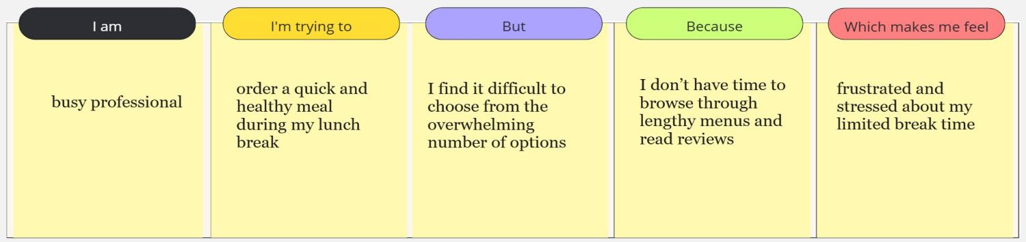

|  |  |  |  |  |  |
| --- | --- | --- | --- | --- | --- |
| **Problem Statement (PS)** | **I am (Customer)** | **I’m trying to** | **But** | **Because** | **Which makes me feel** |
| PS-1 | a customer with late-night cravings | find and order food quickly during late hours | most food delivery options are limited or unavailable late at night | many restaurants close early and few services cater to late-night orders. | frustrated and unsatisfied when I can't get the food I want when I need it. |
| PS-2 | a busy professional | to order a quick and healthy meal during my lunch break | I find it difficult to choose from the overwhelming number of options | I don’t have time to browse through lengthy menus and read reviews | makes me feel frustrated and stressed about my limited break time |